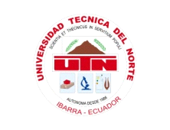
UNIVERSIDAD TÉCNICA DEL NORTE

FACULTAD DE INGENIERÍA EN CIENCIAS APLICADAS

CARRERA DE INGENIERÍA TEXTIL

TRABAJO DE GRADO PREVIA A LA OBTENCIÓN DEL TÍTULO DE INGENIERÍA TEXTIL

TEMA:

APLICACIÓN DEL TEJIDO DE CABUYA CON UN ACABADO FUNGICIDA A BASE DE AJÍ EN CULTIVOS DE FRUTILLA

AUTORA: STEFANY CAROLINA MERINO AVILA

DIRECTOR DE TESIS: ING. EDWIN ROSERO

IBARRA - ECUADOR

2014
APLICACIÓN DEL TEJIDO DE CABUYA CON UN ACABADO FUNGICIDA A BASE DE AJÍ EN CULTIVOS DE FRUTILLA

Autor- Stefany Carolina Merino Avila
Universidad Técnica del Norte, Av. 17 de Julio, Ibarra, Imbabura
carol_teava91@hotmail.com

Abstract. The economic loss in the cultivation of strawberries, due to pests, weeds, diseases and unsuitable soil conditions; has caused the excessive use of chemical pesticides to control them, with the consequent pollution of air, water and soil, and risks to the biotic environment and human health. This makes it essential to finding alternatives to replace the use of agrochemicals, to reduce damage to health and the environment.

The use of padded gardening has lately had a great development since it provides certain agronomic benefits; one of the most used today is padded black polyethylene. However, in return, the main disadvantages of using padding is the price of plastic, handling costs and include the difficulty of fully collecting plastic debris after harvest.

To this end, this project proposes the use of a tissue composed of vegetable fibers, sisal, together impregnated organic pepper based products that allow the substitution of chemicals used in the process of fumigation and in the same way replace the use of polyethylene strawberry crops.

Thanks to the participation and contribution of the textile industry with the application of fabrics sisal with fungicides features you can enter an ecological and viable solution in the agricultural industry, thus benefiting small and large producers of strawberry, seeking to maintain their productivity, taking care of all aspects of culture and in turn seeking alternatives responsible to the environment and human health.

Resumen. La pérdida económica en el cultivo de frutilla, debido al ataque de plagas, maleza, enfermedades y condiciones inapropiadas del suelo; ha provocado el uso desmedido de pesticidas químicos para controlarlas, con la consecuente contaminación del aire, agua y suelo, y riesgos para el medio biótico y la salud humana. Esto hace indispensable la búsqueda de alternativas que sustituyan el uso de los agroquímicos, para reducir daños a la salud y medio ambiente.

La utilización de acolchados en horticultura ha tenido últimamente un gran desarrollo ya que proporciona ciertos beneficios agronómicos, uno de los acolchados más utilizados en la actualidad es de polietileno negro. Sin embargo, como contrapartida, los principales inconvenientes de la utilización de acolchados son el precio del plástico, los costos de manejo y, cabe mencionar, la dificultad de recoger completamente los restos del plástico tras la cosecha.

Para ello, el presente proyecto plantea la utilización de un tejido compuesto por fibras vegetales de cabuya, conjuntamente impregnado de productos orgánicos a base de ají que permita la sustitución de agroquímicos utilizados en el proceso de fumigación y de la misma manera reemplazar el uso de polietileno en cultivos de frutilla.

Gracias a la participación y aporte de la industria textil con la aplicación de tejidos de cabuya con características fungicidas se podrá introducir una solución ecológica y viable en la industria agrícola, beneficiando de esta manera a pequeños y grandes productores de frutilla, que buscan mantener su productividad, cuidando todos los aspectos de cultivo y a su vez buscando alternativas responsables con el medio ambiente y la salud humana.

BACKGROUND

The pepper is widely used in the cuisine to enhance the flavor of foods thanks to the spicy flavor of its flesh and veins, is used in organic farming as an insecticide and insect repellent home. The pulp and veins of peppers contain a high amount of capsaicin, which is a substance of high pungency (feeling hot) which when applied to the insect pests that feed on the leaves of vegetables, creates a burning sensation throughout his body; as a result of its application confirms its repellent effect.

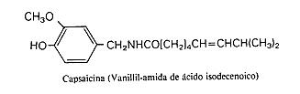

This research was carried out on the farm owned by Mr. Rufo Gordillo, in the sector "El Puente", Urcuquí Canton, Imbabura province, with crops of strawberries of the variety "San Andrea", species imported from USA with a 2 year and 6 month cultivation period.

The experiment combined the evaluation of 3 concentrations of peppers on fabrics 100% sisal, and 50% sisal-50% cotton, to evaluate its fungicidal effect.
The research work aimed to use fabrics of natural fiber with a fungicidal effect to avoid the consumption of chemicals, in crops of strawberry, with the purpose of decreasing the attack of pests, the growth of weeds; providing appropriate conditions to the soil for cultivation, and at the same time being a viable alternative by reducing pollution to the environment and caring about human health.

Within this experimental research, to give fabrics the fungicide characteristics, a process of micro encapsulation of “rocoto” pepper extract was carried out, due to its large concentration of capsaicin as a fungicide and insecticide product; with 3 concentrations of different substances, in ten treatments and three repetitions, at random.

PRACTICAL PART
1. MATERIALS:

Were used and studied the following components:
a. Woven: (100% Sisal) (50% Sisal - 50% Cotton).
b. Substances: chili hot pepper extract, micro silicone emulsion, glycerin, water.
c. Instruments: Pots large capacity, thermometer, measuring cup in milliliters, blender, stir bar, balance, gas stove, stopwatch, measuring containers for chemicals.
d. Other materials: PH Paper, Stiletto, scissors, thread, sisal, needle, plastic bags, mask, gloves, apron.

2. TREATMENTS:

Table 2. Treatments studied in the evaluation of three concentrations of pepper in crop strawberry (species San Andrea), in the county Urcuquí province of Imbabura.

3. TEXTILE PROCESS:

DIAGRAM OF TEXTILE FUNGICIDAL PROCESS

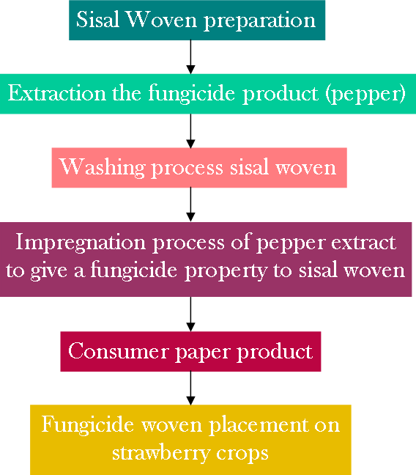
To the impregnation process of pepper extract to give a fungicide property to sisal woven, I used a consumer paper product with the textile process and products information:

5. EFFICIENCY EVALUATION OF THE FUNGICIDE PRODUCT IN THE STRAWBERRIE CROP:
I used a table to control the results of fungicidal woven on crops of strawberries with the following information:

This table showed the initial values of the state of strawberries crop and highlighted the progress achieved after application of fungicidal woven and thus assess its efficiency.

Further testing pH and temperature of the strawberry crop land were conducted to identify a possible attack by fungi.

6. INTERPRETATION OF RESULTS:

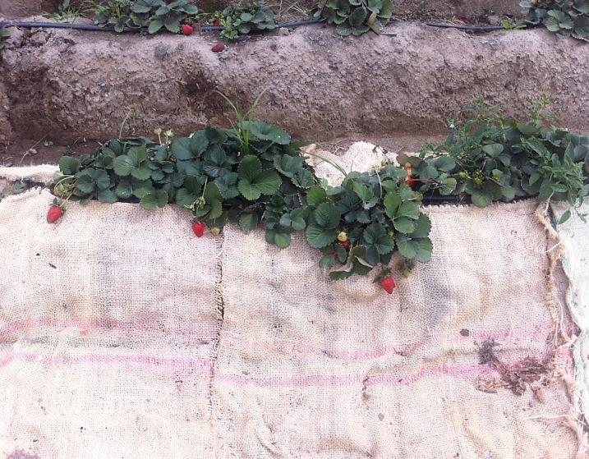
After evaluation of fungicidal woven action for 33 days in strawberry crop was reached to obtain results that allowed me to differentiate the efficiency of each woven and different concentrations, for this were used graphics.

At each assessment could demonstrate greater efficiency of 100% sisal woven with 100% concentration of pepper in the control of undergrowth, spiders and acarus.

7. UNIT PRICE:
The price of each woven was calculated using the cost of each product used for processing, for it was taken into account materials direct, indirect and direct labor.

WOVEN COMPOSITION | ROCOTO PEPPER CONCENTRATION | UNIT PRICE
Sisal | 100% | $5,816
 | 50% | $5,311
 | 10% | $4,806
Cotton + Sisal | 100% | $7,043
 | 50% | $6,769
 | 10% | $6,579

The unit price varies according to the pepper concentration and the type of woven, since the cost of woven sisal and cotton mixture was highest, while the higher the pepper concentration was the price higher of the fungicidal woven.

8. ADVANTAGES IN THE USE OF THE FUNGICIDAL WOVEN RELATIVE TO THE POLYETHYLENE MATERIAL IN STRAWBERRY CROPS:

Sisal Fungicidal Woven:
a. Less impact on ecosystems with use it.
b. The use of organic products in the cultivation secures good fruit grown without the use of chemicals products for fumigation, ie without risk of health conditions for the end consumer.
c. Development costs are very low in relation to the acquisition of chemicals with similar properties for pest control in strawberry crops.
d. Being a fungicidal woven with insecticides characteristics, avoids the use of any additional chemical in the crop, representing a significant saving.
d. Being biodegradable, the fiber is used as a natural blanket for protecting strawberry crops, avoids collect it and reduces costs.

Polyethylene plastic mulch:
a. Reduce the incidence of undergrowth.
b. Increased performance and advance harvest, improves product quality.
c. The soil covered with polyethylene has higher temperature than bare soil and thus the humidity increases.
d. The polyethylene material for crops has a cost of $ 100 per 1000 meters, making it a relatively inexpensive product.

9. DISADVANTAGES IN THE USE OF THE FUNGICIDAL WOVEN RELATIVE TO THE POLYETHYLENE MATERIAL IN STRAWBERRY CROPS:

Sisal Fungicidal Woven:
a. The cost of woven fungicide with a measures of 70 cm x 2m varies between $ 4.80 and $ 5.80 depending on the percentage concentration of fungicide (rocoto pepper); relatively high costs relative to the polyethylene material.
b. When exposed to excessive moisture and weather variables, the woven may lose its properties over time.
c. Currently the national production of sisal 100% woven is reduces, thereby greatly increasing their costs, which could result in price variation in the development of fungicidal woven.

Polyethylene plastic mulch:
a. Attack of undergrowth may appear between guachos, for which it is necessary to use other chemicals, including undergrowth emergence occurs in the planting hole, which cause serious problems for the strawberries.
b. The high density polyethylene used in crops, have a short shelf life, especially in the period of greatest radiation, suffering a sharp deterioration before completing the period of crop, becoming a contaminate residue of high impact.
c. By retaining the temperature and humidity, this material in warmer times produces burns on the foliage of plants and appear pathological fungal diseases, all of which must be treated with harsh chemicals.
d. Since this is a product used in crop protection, non-combat attack of pests such as insects, fungi or other problems, since its purpose is to prevent undergrowth growth; is for this reason that the crop needs of other complementary products to combat these evils; thereby increasing the costs of production of the strawberries.

CONCLUSIONS:

1. Due to climatic and geological characteristics of the experimental site was not found any fungal attack ; however was found a high percentage of attack of spiders, acarus and undergrowth in the strawberries crop, San Andrea variety.

2. The use of a woven of fibers vegetable similar, benefits with the use of polyethylene material commonly used in strawberry crops, such as protection of the ground contact of the fruit, decrease of undergrowth overgrowth and the appearance of insects; however the woven showed that greater benefits, being a friendly product with de environment and biodegradable.

3. The fungicidal woven use gave good results in controlling pests through the use of a high performance component pesticide such as the naturally occurring rocoto pepper, allowing replacement of chemicals in many cases harmful to human health; thus, a product friendly with the environment, responsible with the living and efficient with strawberry crop.

4. Greater control of pests and undergrowth in crops of strawberry variety San Andreas, did the sisal woven 100% at a concentration of 100% of rocoto pepper, and showed a 15% higher efficiency than other concentrations and compositions of fibers with which it was tested.

5. Woven 100% sisal with a concentration of pepper 100% showed positive influence on crop yield as an efficiency of 100% was obtained compared to the witness.

6. The PH obtained at different concentrations and woven showed excellent results to avoid the appearance of fungi in crops as they were within the permissible range (6.5 to 7.5).

7. Woven from 50% cabuya-50% cotton showed some appearance of worms and beetles in the rainy season, however sisal woven remained free of pests.

8. The highest net profit was obtained with 100% sisal woven, primarily with low concentration, due to lower consumption of chemicals and the minimum cost of woven sisal recycled.

RECOMMENDATIONS:

1. Is needed textile process in a laboratory in the same area, equipped with the materials and tools needed to ensure the success of the process.

2. The use of protective equipment for use of different substances in the textile process is recommended; the use of mask, apron, goggles and gloves, avoid irritating upon contact with chili hot pepper extract due to its high concentration.
3. The application of woven with their respective concentrations should be in a longer period of time in order to evaluate the durability of the same in the crop of strawberries.
4. It is recommended the use of other natural products used ancestrally for pest control in crops such as guanto, garlic, alfalfa, in combination with pepper to improve the efficiency of the final product.
5. It is important to an analysis of PH in each bathroom during the impregnation process of chili hot pepper extract to ensure that the final product has a PH 6.5 (slightly acidic) recommended for any crop, preventing the growth of fungi and bacteria; and in turn helping to complete exhaustion of the micro emulsion of the silicone in the bathroom.

6. It is advisable to make the entire process of planting and cultivation of strawberries to evaluate the efficiency of tissue throughout the course of this.

7. Use sisal woven with a concentration of 100% of rocoto pepper to control undergrowth and pests in strawberries crop, due to its considerable economic value and its high percentage of efficiency is recommended.

BIBLIOGRAPHY:

*Ing. Berardocco, H. Acolchado plástico.

*Ing. Agr. Gepp,V, MSc. e Ing. Agr. Mondino, P, PhD. (2011). Control químico.

*Macua,J., Lahoz, I., Calvillo, S., Garnica, J., Santos, A., y Díaz, E. Utilización de Acolchados plásticos en tomate y pimiento.

*Almeida, A. y Vásquez, F. (2011). Estudio de factibilidad para la creación de un centro de acopio e industrialización de ají en el valle del Chota.

*Enriquez, S. (2006). Proyecto de factibilidad para la producción y exportación de fibra de cabuya (agave, spp) a españa, periodo 2006 – 2015.

*Ing. Agr. Cassanello, M. (2008). Enfermedades de frutilla y su manejo.

*file:///E:/Anteproyecto/Los%20fungicidas%20naturales%20para%20combatir%20plagas%20del%20huerto%20%20%20ECOagricultor.htm

*file:///E:/Anteproyecto/TIPOS%20DE%20TEJIDOS%20%20TEXTILES%20Y%20TIPOS%20DE%20TEJIDOS.htm

*file:///E:/Anteproyecto/Mezcla%20de%20agrot%C3%B3xicos%20y%20efectos%20en%20la%20salud.htm

*file:///E:/Anteproyecto/Manejo%20integrado%20del%20cultivo%20de%20frutillas%20%C2%AB%20Revista%20EL%20Agro%20Ecuador.htm

*file:///E:/Anteproyecto/fertilizando_el_cultivo_d.html

*file:///E:/Anteproyecto/frutilla-cultivo-rentable_0_551344982.html

*file:///E:/Anteproyecto/CABUYA.htm

*file:///E:/Anteproyecto/AL_000011ho.htm

