Translator Device from the Sign Language of the Deaf into Auditory Sounds of the Letters of the Alphabet

Harold Carrasco, Lennin Encalada, David Narvaez
Universidad Técnica del Norte, Ibarra - Ecuador

Summary
The deaf in our country have not been provided with tools that allow them to be truly included in society. We have created a tool that translates the sign language that signing people use daily into auditory sounds that people who have normal hearing can recognize. This was achieved by endowing a glove with sensors that register each sign that the signing person makes, and then sending it to a processing unit. Once the extracted signal is recognized as valid, a unique command for it is sent to a cell phone via Bluetooth, which will trigger the reproduction of the captured signal’s corresponding sound.

1. Introduction
In Ecuador, people with disabilities have been held under begging and charity conditions. People with verbal and auditory disabilities communicate with one another by signs made with the hands or position of the fingers.
Different tools have been provided to enhance the communication and inclusion of all people with this type of disability, although tools that enhance communication between these people with the rest of society have not yet been provided.
This project is aimed to comply with the constitution of the Republic of Ecuador, which in one of its articles guarantees “the access to mechanisms, means, and alternative forms of communication, among them sign language for the deaf, oralism, and the Braille system,” especially in the “elimination of physical, psychological, social and communicational barriers.”

a. Sign Language with the Movement of the Hands

Ecuadorian Sign Language (LSEC—Spanish Acronym)

The deaf, lacking of the auditory channel, developed a language that was more suitable for their communicative needs. This was called “Sign Language.” Contrary to what many people believe, the sign language that the deaf use is not universal. The deaf community of each country elaborated and developed a sign language that is adapted to the characteristics of each community.
Ecuadorian Sign Language (LSEC) is the language that has been developed over the years and passed on throughout the deaf community of Ecuador. This language has a visual-gestural form and the same properties as the natural oral languages. By means of it the deaf can communicate, transmit desires and interests, inform themselves, defend their rights and construct a positive identity that makes them members of their community.
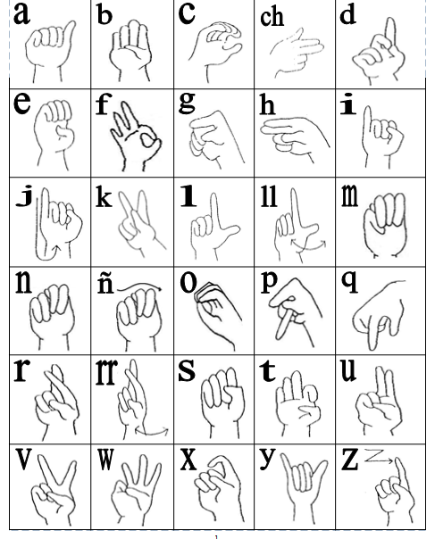
Figure 1
Source: Ecuadorian Alphabet Recognized by the National Federation of the Deaf of Ecuador

The system which will be developed propses to establish a means of communication between people who have auditory disabilities and those who do not, and do not know sign language (see Figure 1). The desire is to cause the least amount of impact possible on either of the participants of the conversation. In order to achieve this, the sign language that the deaf already know will be translated into sounds which are clearly percetible to non-signing speakers.
In the same way, this system can be used by people who were not necessarily born with this disability, however do not have the capacity to create sounds.

II. Materials and Methods

To begin the construction of the device we must first determine what, exactly, we want to achieve with it. If the different letters of the alphabet have a unique position, this will be what the system should capture.
Since the hand of the signing person moves in space, we should determine: the position of each finger, the position of the hand in space, and the speed with which it moves. These three aspects being the most important to measure, we can now project a model for the device.
Once these signals are acquired, we need a unit that will process and administer the obtained information and then externalize said signal in audio form as the non-signing person waits.
Figure 2 indicates the general functioning of the device, in which are shown the instruments, which could give the aforementioned signals.
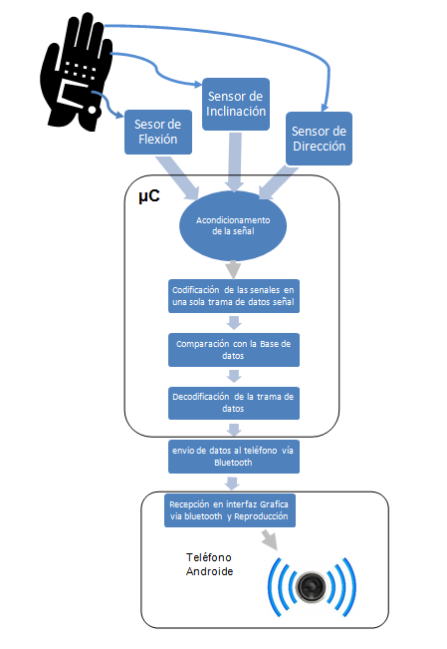
Figure 2
Source: The Authors

a. Capacitive Accelorometer

An electric accelerometer is a device which registers the variations of gravity on one or all of the axes, since it possesses a seismic element that reacts to the force of gravity of the medium which is applied to it. Upon varying the amount of force measured by effects of gravity, the proportional voltage emitted by the accelerometer will also vary. This is the data that will allow us to digitalize the amount of registered acceleration.

b. Conditioning of Flex Sensors Signals

As a light introduction, we will begin by indicting what is a strain gauge:
A strain gauge or extensionometer is a sensor based in the piezoresistive effect. A stress that deforms the gauge produces a variation in its electrical resistence. The materials which are frequently used to make gauges are metallic alloys, for example: nichrome, or semiconductor elements, like silicon and germanium. It is because of that that we can classify gauges into two types: metallic and semiconductors.
From this concept of the strain gauge comes the beginning of the functioning of the flex sensors.
The felx sensor bases its resistence in carbon. When the sensor is bent, the resistence vaires in relation to the radius of the curvature: the less the radius, the greater the value of resistence (no curve= 9k ohm, bent at 90 degrees= 14k ohm, bent at 180 degrees= 22k ohm).
For its conditioning, we used only a wheatstone bridge (Figure 5), by means of which we obtained a voltage signal proportional to the variation of resistence. This signl can then be easily valued by the microcontroler. So that the voltage signal be correct in order to produce an accurate signal, we used the following formula to calculate the values of the rest of the resistence of the wheatstone bridge:
gramation of the aplication of the cell phone, as in the microcontroler program should be specified: how many bytes will be recieved, what type will be sent, the speed of the transmission and the parity, to name the most significant. This will allow that the devices be synchronized in the moment of communication, a process which is shown in Figure 4.

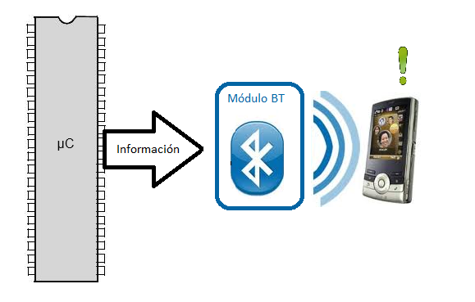
Figure 4

c. Reproduction by Means of an Android Phone
The cell phone is an important factor in creating the device we wish to create. It should be a phone with an Android opertating system with the ability to create aplications using a JAVA platform with programming oriented towards objects. This can be achieved by a virtual machine called App Inventor, created by the Google company and perfected by the university MIT. This application consists of two parts: the explorer and the block editor. All of this software, according to its creators, was designed so that the users not only participate as customers, but also as creators of the technology that they have in their hands. From there, the versitility of said way of programming allows people with little programming knowledge to create fit and intuitive applications.
To create an application, the first thing to do is give it an appearance and a body, things which will be provided by the explorer, as shown in Figure 5.

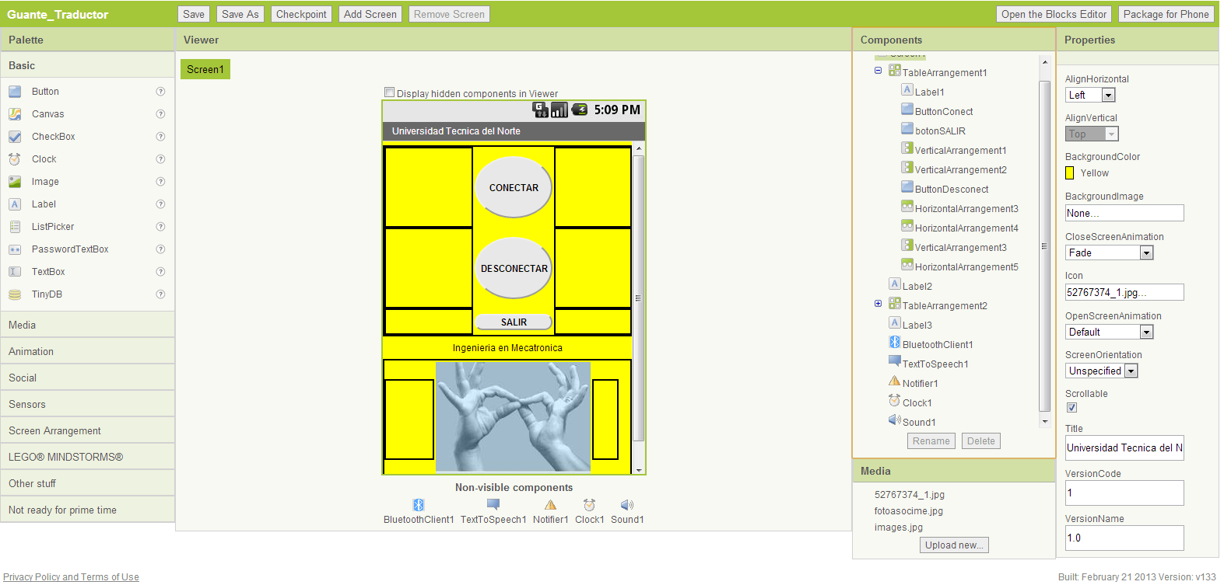
Figure 5

The second part of the App Inventor shows the block editor, where one begins the programming as such. It is here where one has the capacity to control the blocks used and the manner in which they interact with the other blocks.

III. Results
The moment in which all the necessary elements come together for the optimal functioning of the device proved the functioning of all of them in real scenarios, thus verifying the interaction of all the components. Below we show the configuration of all the components in relation to the microcontroller, this being that which coordinates the general manner of the operations performed by the device.

a. Communication between the Flex Sensors and the Microcontroller Xmega128A1
For the implementation of the flex sensors in the device, we used the diagram in Figure 9, using Xmega128A1 software functions, with a signal acquisition time of T=1.09ms. We used the two analogous digital converters which the microcontroller possesses.
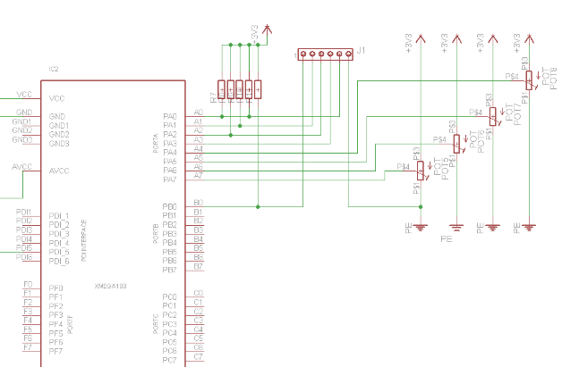
It was established by means of thresholds and an allocation of position in the data frame, which corresponds to the three positions of each of the fingers as seen in Table 1.

Figure 7

Table 1 Allocation of Bits Corresponding to the Data Frame Used for the Flex Sensors
Source: The Authors

b. Communication between the Accelerometer MMA7361 and the Microcontroller Xmega128A1.
For the implementation of the accelerometer we used the diagram in Figure 10 and the configuration of the ADC converter is the same configuration as the ADC-B channel and the channels ADC1, ADC2, ADC3 T=1.09ms.

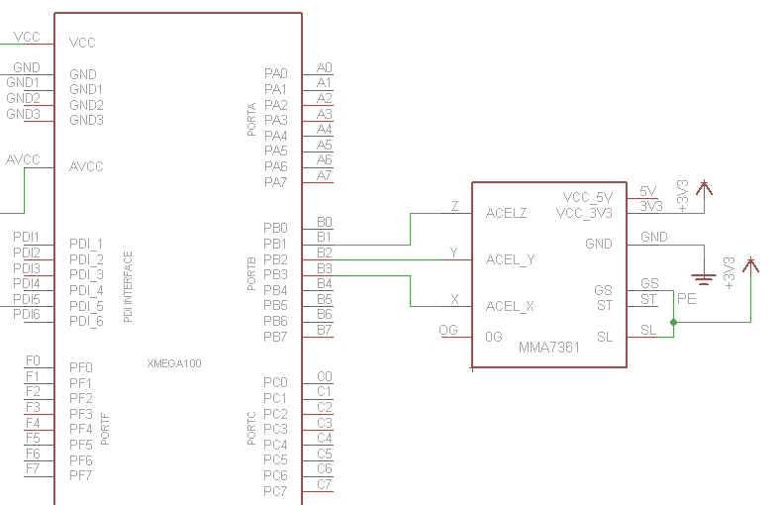

Figure 8

It was established by means of thresholds and an allocation of position in the data frame, which corresponds to the three positions of each of the fingers as seen in Table 2.

Table 2 Allocation of Bits Corresponding to the Data Frame Used in the Axes of the Accelerometer MMA7361.
Source: The Authors

c. Communication between the Microcontroller and the GY-26 Compass
In accordance with the data provided by the maker, we took the reference data from the four cardinal points—North, South, East, and West—as is indicated in Figure 11, comparing this with a direction-measuring instrument, with regard to Magnetic North.
We compared the direction given by the physical instrument with the data given by the device in digital form.

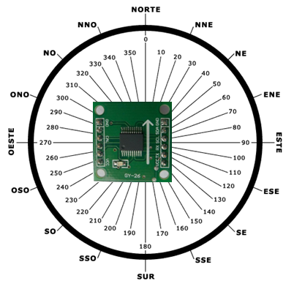

Figure 9

This data was obtained using the hyper-terminal provided by the compiler Codevision, Figure 12.

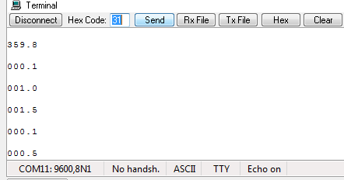

Figure 10
Source: The Authors

d. Communication with the Cell Phone
As was indicated the section on materials and methods, the application consists of two parts. In the part of explorer is given: the name of the application, a screen background, background color and other aspects that favor a good visual appearance. Once this has been done, one adds interaction elements. As shown in Figure 7, we have:
- buttons
- labels and screen organizers used as spacers

In the case of this application buttons were added within the visual components. Within the non-visual components we have:
- Bluetooth customer component
- Text-voice converter
- Timer
- A sound file reproducer

The second part, where one programs the interaction between the blocks and with external elements, is performed in the block editor using the said program oriented toward objects, as shown in Figure 11, which is a short fragment of the program.

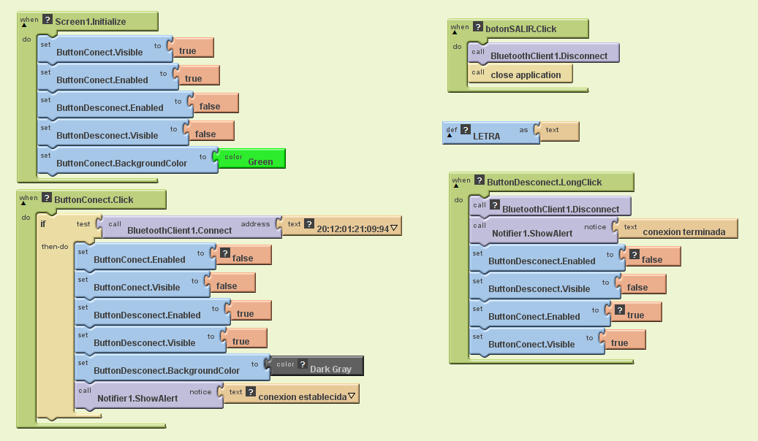

Figure 11

e. Functioning Tests
The functioning tests for the device were done in the Deaf Education Unit of the Provincial Government of Imbabura, located in the city of Ibarra. The tests were applied to non-hearing people of both sexes, belonging to a high school class. To obtain real results we performed two types of tests: threshold calibration and repetitivity.
- Threshold Calibration Tests:
In this test we used the translator device to make sure that the users make the movements of the alphabet, and consequently that the electronic parts preceive this data. In addition to this, we used a GLCD screen to visualize the obtained values in each position that the sensors recieved.
- Repetitivity Tests
In this test we considered the modifications made in the thresholds to verify if the results were what was expected. To obtain accurate results we asked each individual to make the sign for each letter of the alphabet 10 times, and in this way register the correct movements and the errors. This showed the accuracy of the device. In the same way, this test helped to determine with which letters the device was more likely to fail, creating a mean of the results obtained from all the users.

IV. Discussion and Conclusion

- After performig the tests with non-hearing people, the impresions of the users were of great prospect, such that this tool, once comercialized, will be of great help in the moment of communication with people who do not know sign language.
- For the calibration of the device it was necessary to perform the tests with non-hearing people, since the movements that they make are those that the glove should translate.
- The development of platforms that implement applications under free software, like App Inventor, shortened the development time of the application for the adroid phone and its interface via Bluetooth

V. Recommendations
- It is necessary that the person who is using the glove have good mobility of the fingers, and that he or she not exceed size medium since this could cause irreversible damage to the device sensors, mainly in the flex sensors.
- If when connecting the device and the Bluetooth errors occur that are not considered in the users’ manual, one should contact the project authors.
- The mass production of this device would lessen the costs of production, which would make it more accessible to the population which needs it.
- Frequently check to see that the batteries are in good shape and also that the sensor cables are not damaged.
- Avoid sun and dust exposure.
- Under no circumstances allow the device enter contact with water or humidity.
- Change between letters with the most fluidity possible, otherwise the glove may understand that it should translate some other motion.
- In the case of the letters M, N, U, F, K, and P, make as much contact possible with the copper finger plates so as not to create confusions.
- For future investigations, one should take into consideration that letters such as S and Z can be improved, and continue development with both hands, being able to make expressions this way.
- In future investigations, the implementation of neuronal nets would be convenient to achieve that the device interpret the user’s behavior in the most accurate way, also the movements of the elbow and forearm.

VI. Acknowledgements
As authors of this project, we are thankful for the colaboration of the School of the Deaf of the Provincial Government of Imbabura, who contributed in our investigation and helped us to perform the functioning tests. Also to the engineers Danny Pabón, David Narvaez, and Gerardo Collaguazo.

VII. References
- (2007), MICROCHIP TECHNOLOGY INC, PIC18F2455/2550/4455/4550 Data Sheet
- Consultado el 17 de Febrero del 2011.
- User Guide SOMO Audio Converter Software Tool
- Consultado el 1 de Marzo del 2011
- SOMO-14D Embedded Audio-Sound Module Data Sheet
- Consultado el 1 de Marzo del 2011
- Guía rápida del módulo de reproducción de ficheros de sonidos SOMO – 14D
- Consultado el 13 de Marzo del 2011
- SOMO-14D-applications2.pdf
- Consultado el 20 de Marzo del 2011
- Primera Ley de Discapacidades.- Registro oficial
- Consultado el 28 de Febrero del 2011
- Microcontrolador. Consultado el 17 de Abril del 2011 en:
- http://es.wikipedia.org/wiki/Microcontrolador
- Luis E. Sánchez Toledo. Microcontroladores genéricos. Consultado el 17 de Abril del 2011 en:
- http://www.monografias.com/trabajos34/microcontroladores-genericos/microcontroladores-genericos.shtml
- LCD. Consultado el 30 de mayo del 2011 en:
- http://www.todorobot.com.ar/documentos/display.pdf
- http://www.pablin.com.ar/electron/info/lcd/index.htm
- http://www2.ing.puc.cl/~iee2782/LCD.jpg

- Programa de discapacidades en el Ecuador. Consultado el 24 de Mayo del 2011 en: http://www.vicepresidencia.gob.ec/programas

- Estadísticas del último censo de personas con discapacidades en el Ecuador. Consultado el 24 de mayo del 2011
- http://www.conadis.gob.ec/estadisticas.htm

- Aplicaciones con el módulo SOMO-14D http://www.enchantedlearning.com/themes/asl.shtml
- Hoja de datos del sensor de flexión
- http://www.sparkfun.com/datasheets/Sensors/Flex/FLEXSENSOR(REVA1).pdf
- http://es.wikipedia.org/wiki/Puente_de_Wheatstone
- MAYNE, J. (2003). Sensores Acondicionadores y Procesadores de señal.

VII. Biographies
Luis D. Narvaez Erazo was born in Ibarra, Ecuador on October 26, 1985. He carried out his secondary studies at Teodoro Gómez de la Torre high school, where he obtained the degree of Bachelor in Sciences, with a focus in Mathematical Physics. He graduated from Universidad Técnica del Norte as Engineer in Electronics and Communication Networks in 2012. Currently he is a professor at Universidad Técnica del Norte in the Faculty of Engineering in Applied Sciences.
Areas of interest: robotics, industrial control, electrical networks, microcontrolers. (davnarvaez@hotmail.com)

Harold E. Carrasco Cueva was born in Atuntaqui, Ecuador on February 3, 1987. He carried out his secondary studies in Colegio Fisco-misional “San Francisco.” where he obtained to degree of Bachelor in Humanities, with a focus in Physics-Mathematics. Currently he is a graduate of the major Mechatronic Engineering at the Universidad Técnica del Norte.
Areas of interest: mechanics, robotics, automation, languages, religion. (haroldcessna@hotmail.com)

Lennin C. Encalada Monteros was born in Ibarra, Ecuador on November 19, 1989. He carried out his secondary studies in Colegio Fisco-misional Sánchez y Cifuentes, where he obtained the degree of Bachelor in Physics-Mathematics. Currently he is a graduate of the major Mechatronic Engineering at the Universidad Técnica del Norte.
Areas of interest: robotics, industrial and mechanical automation.
(lennine_10@hotmail.com)

Constitution of the Republic of Ecuador. Chapter six. People with Disability. Article 46, II.
CONADIS Law. Taken from the Official Record No. 250, April 13, 2006.
Dactilogical Alphabet recognized in Ecuador. Source: CONADIS.

